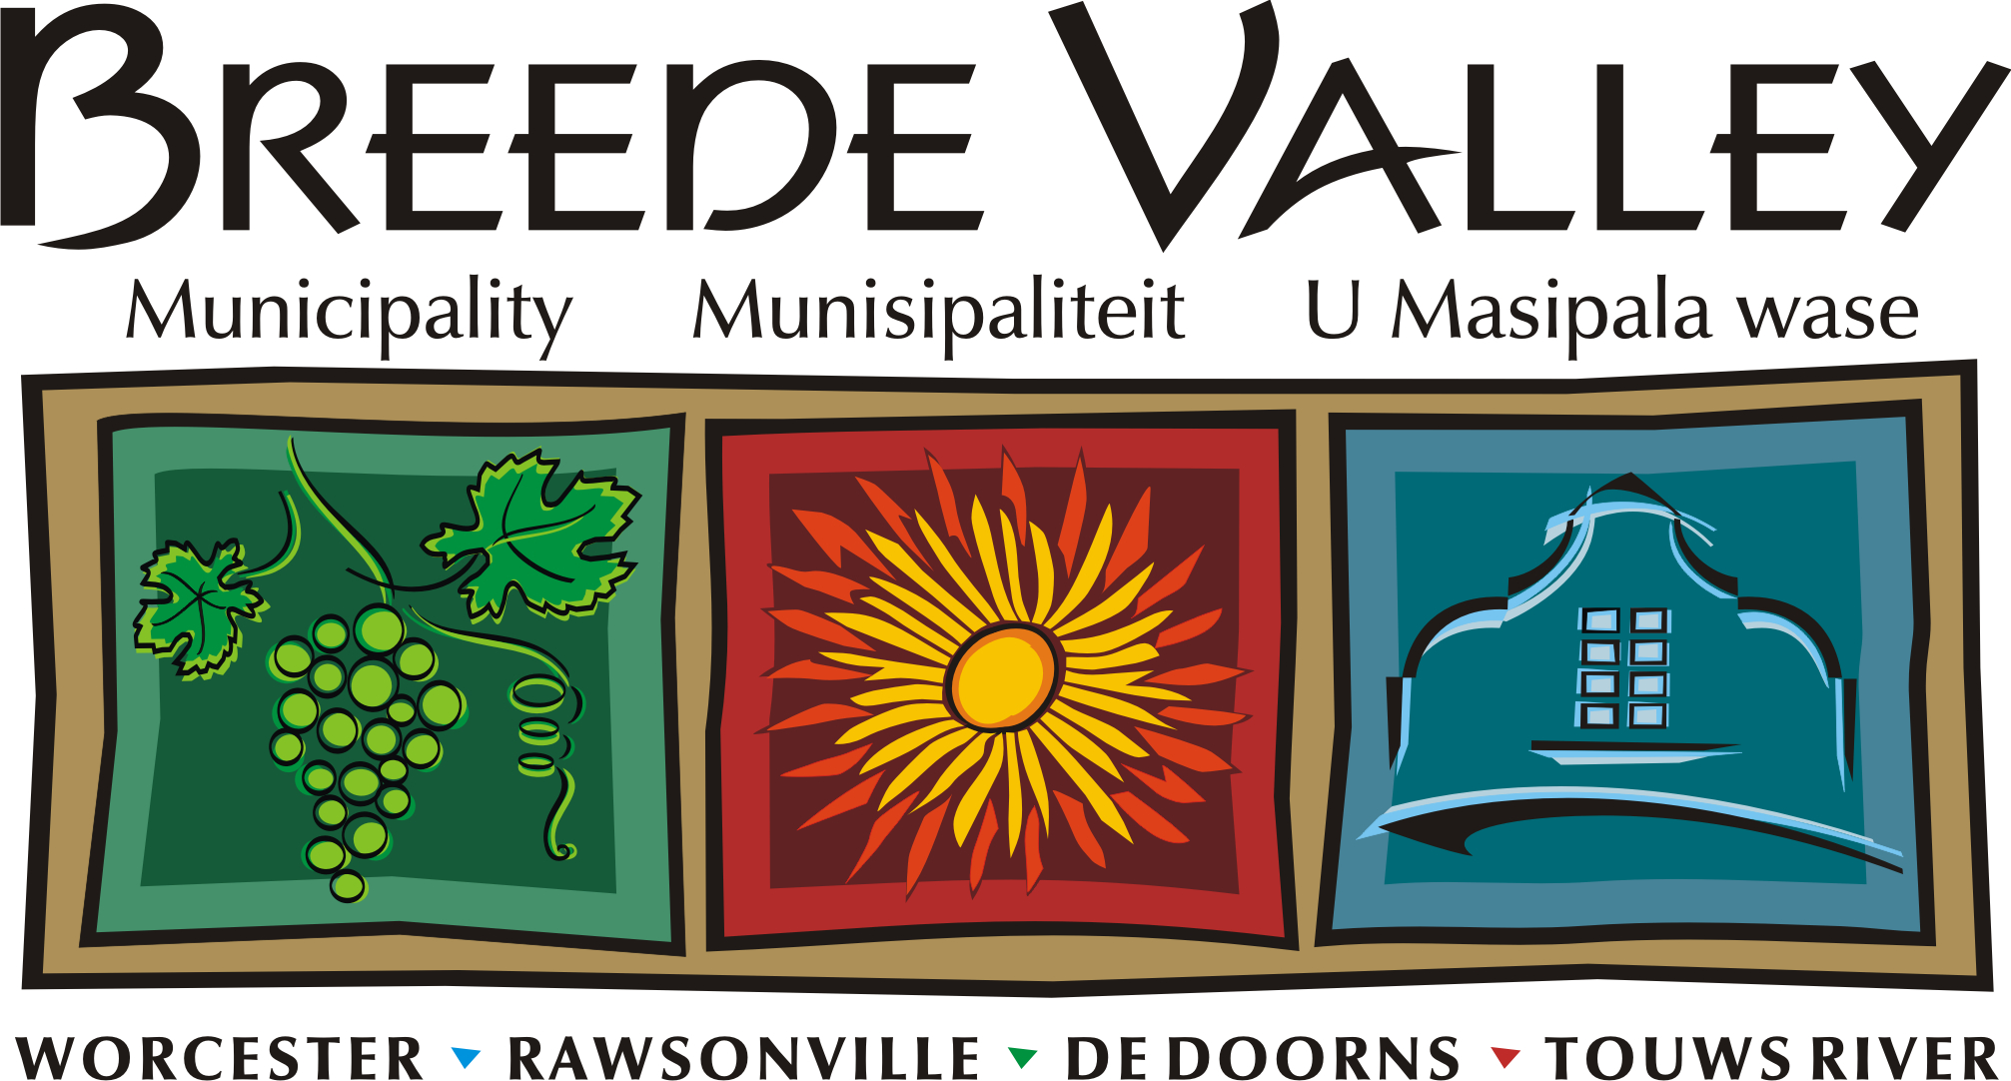
’n Unieke en sorgsame Vallei van uitmuntende dienslewering, geleenthede en groei.
Intlambo ekhethekileyo enenkathalo, egqwesayo kuniko-zinkonzo, ivulela amathuba kwaye iphuhlise.
A unique and caring Valley of service excellence, opportunities and growth.

Interne Memorandum / Internal Memorandum

Van/From: Cllr: ___________

Aan/To: Mr. R Esau, Director Strategic Support,
Datum/Date: 29 January 2018

Conferment of Honorary Title of Alderman on Cllr:__________

The above matter refers. I herewith apply to be bestowed the title of Alderman.

In compliance with paragraph 3.3.1.1. of Council’s Conferment of Civic Honours Policy’, a Councillor who has served on one or more local governmental bodies within the Republic of South Africa for a total period of 20 years or more, provided that the term of office need not be consecutive and includes any term of office prior to 1 February 1995, being the date of commencement of the pre-interim phase of the local government transition may be bestowed the title of Alderman.
No. | Name of Municipality Served | Actual dates served (example 1 May 1996 to 29 January 2018) | Completed Years served
1.
2.
3.
4.
5.
6.
7.
8.
9.
10.
(Please complete a new line if period was interrupted – including interruption by elections)

I thus served as municipal Councillor for more than 20 years.
Please find attach proof.

Yours

____________
Cllr:

