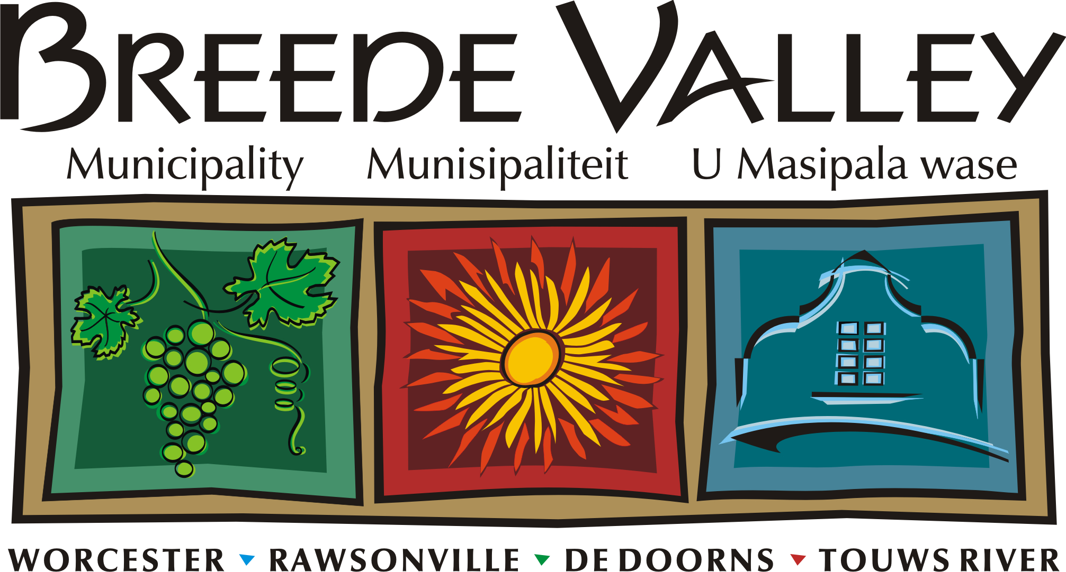
’n Unieke en sorgsame Vallei van uitmuntende dienslewering, geleenthede en groei.
Intlambo ekhethekileyo enenkathalo, egqwesayo kuniko-zinkonzo, ivulela amathuba kwaye iphuhlise.
A unique and caring Valley of service excellence, opportunities and growth.

Interne Memorandum / Internal Memorandum

Van/From: Cllr: ___________

Aan/To: Mr. R Esau, Director Strategic Support,
Datum/Date: 29 January 2018

Conferment of Honorary Title of Alderman on Cllr:__________

The above matter refers. I herewith apply to be bestowed the title of Alderman.

In compliance with paragraph 3.3.1.2. of Council’s Conferment of Civic Honours Policy’, a Councillor of the Municipality of Breede Valley upon the assumption and occupation of the Office of Mayor for a continuous period in excess of 3 years (36 calendar months) provided that this provision does not apply to the position of Acting Mayor may be stowed with the title of Alderman.

I have served as Mayor of ______________________ Municipality (name) for an uninterrupted period from ___________(date) to __________(date) being a term of ___________(months)

I thus served as mayor for more than 36 continuous months.
Please find attach proof.
Yours

____________

Cllr:

