Nekkies Conference Centre and Accommodation
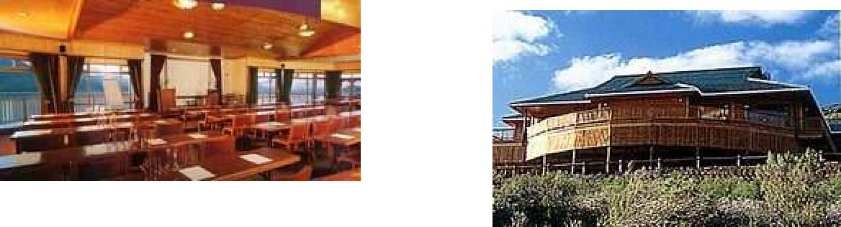

Built of stone brick and wood to blend pleasantly into the natural environment, our Conference Centre commands a spectacular view of the lake and surrounding areas. The centre is fully air-conditioned, has two breakaway rooms, a tearoom and can accommodate up to 120 delegates. The elegant wooden furniture can be arranged to suit your requirements. The following audio visual equipment is available: *Sound system - collar, cordless and fixed microphone, *Big screen projector for video, computer and TV, *Satellite TV, video and CD, *Slide

projector, *Overhead projector, *White board, flipchart, lectren, *Wall exhibition space.
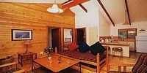

Each chalet has two bedrooms with en suite bathrooms, two single beds per room and a fully equipped kitchenette for self-catering.
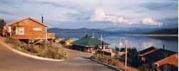

Our luxury wooden chalets, built on stilts, offer breathtaking views of the lake and mountains.
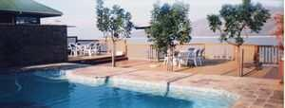

Our comfortable recreation hall offers multi-channel TV, a bar and indoor and outdoor braai areas. Both the river and the dam has excellent fishing (carp, bass and trout), hiking and mountain trails. There are bicycles for hire and the water sport facilities of neighbouring yacht club are available to visitors who bring their own boats. Canoe trips, wine tasting and cellar tours, horse riding and golf can be arranged on request.

Conference goers can enjoy the exclusive service of our kitchen. We will gladly discuss your requirements, form farm breakfasts to lunches, dinners, braais, etc.
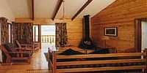

Bed linen and towels are provided and each chalet has its own telephone. There is a private balcony, braai area, an inside fireplace for cold winter nights, as well as fans to keep you cool in summer. (Satour graded)
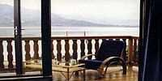

We provide 24-hour security, entry control and plenty of parking space.
Fax and photocopying services are available.

Enquiries/Reservations/Map
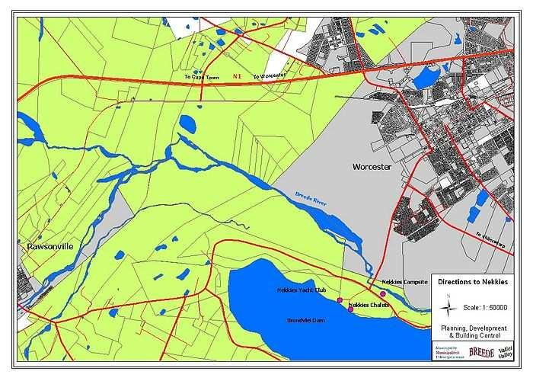

Nekkies Lake Chalets
Private Bag X3046

Worcester 6849
Tel.: +27 23 343 2909 / +27 23 348 2930
Fax: +27 23 343 2910 nekkies@bvm.gov.za

