Camping Site Resort and Camping Site
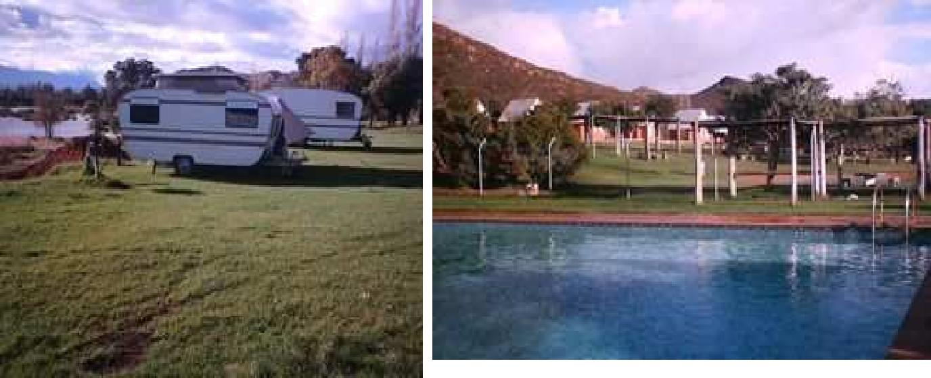

Nekkies resort & campsite are situated on the banks of the Breede River, approximately 4.5 km outside Worcester on the Rawsonville road. Day visitors are welcome form 08h00 till 18h00.

Accommodation consist of self catering chalets - no bedding, TV and microwave. The campsite consist of 20 powerpoints for caravans and tents and 80 sites without power, all sites are on grass. We have warm water ablution facilities, a big swimming pool and a pool for toddlers.

Enquiries/Reservations
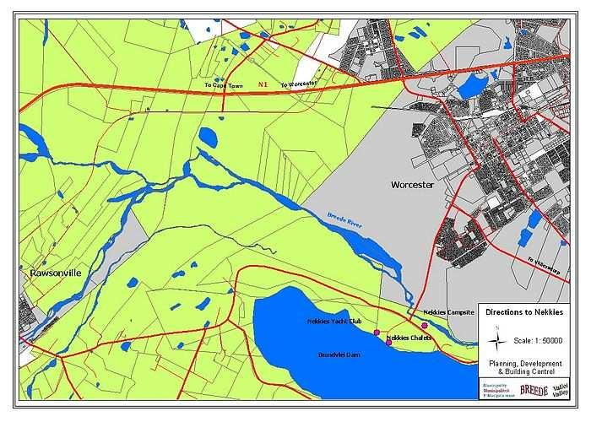
Tel: +27 23 343 2909 / +27 23 348 2930

Fax: +27 23 343 2910

nekkies@bvm.gov.za

